B.M.S College of Engineering Department of Machine Learning

# Data visualization Lab

**M Shrawan Matrubai Prof. Arun Kumar**

# **1BM21AI062 Dept of ML**

**5B**

# **12-01-2024**

Q: Use prediction profiler to find best process conditions that maximizes desirability. Perform Monte Carlo Simulation and Simulation experiment to desire a robust solution.

1. Open the JMP software.

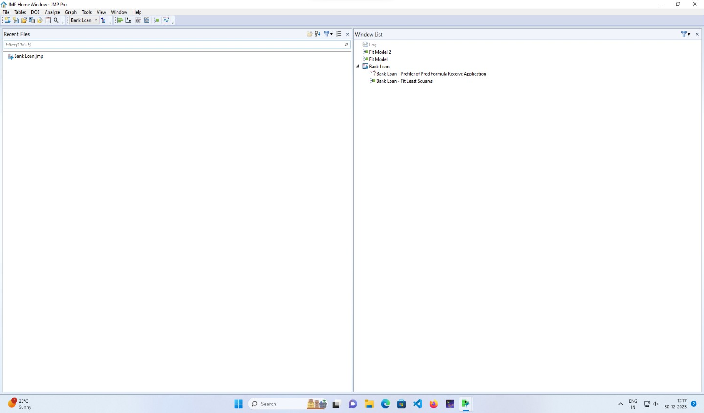

1. Import a CSV file.

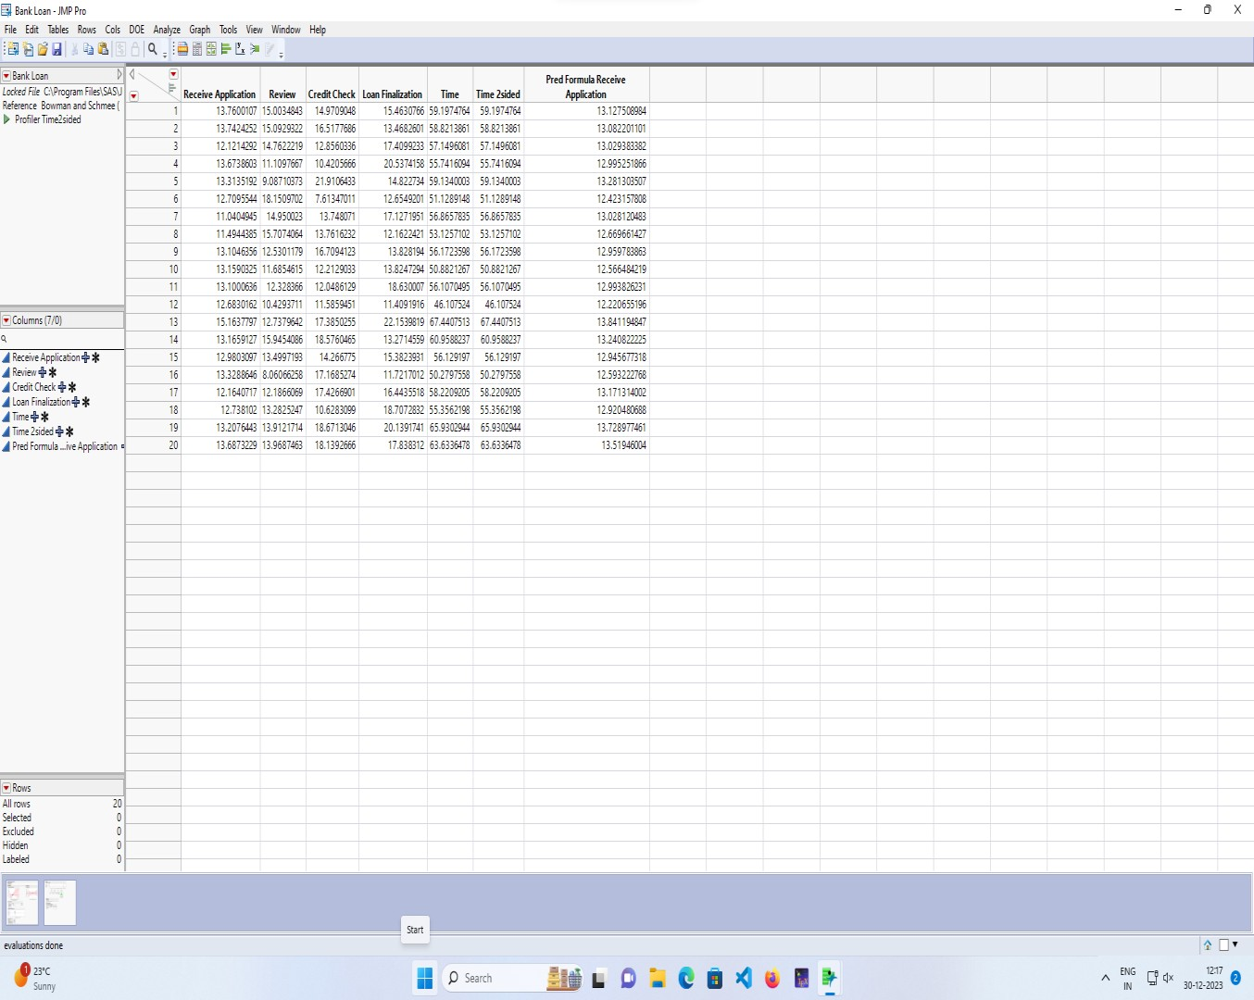

1. Use the fit model option in analyze in the file menu.

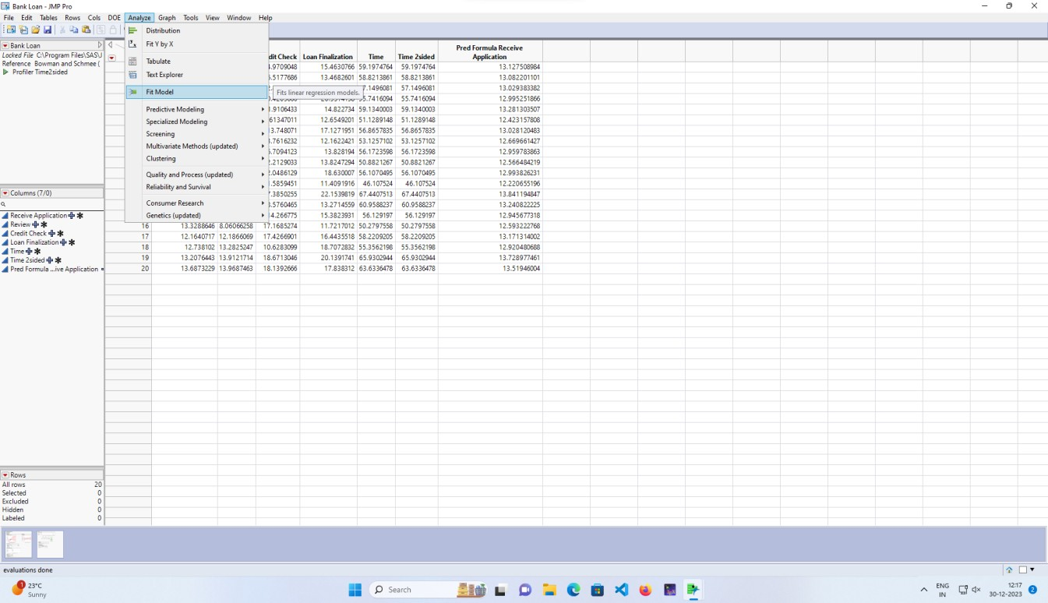

1. Give the input to Y axis from the set of columns in dataset, add the columns to construct model effects.

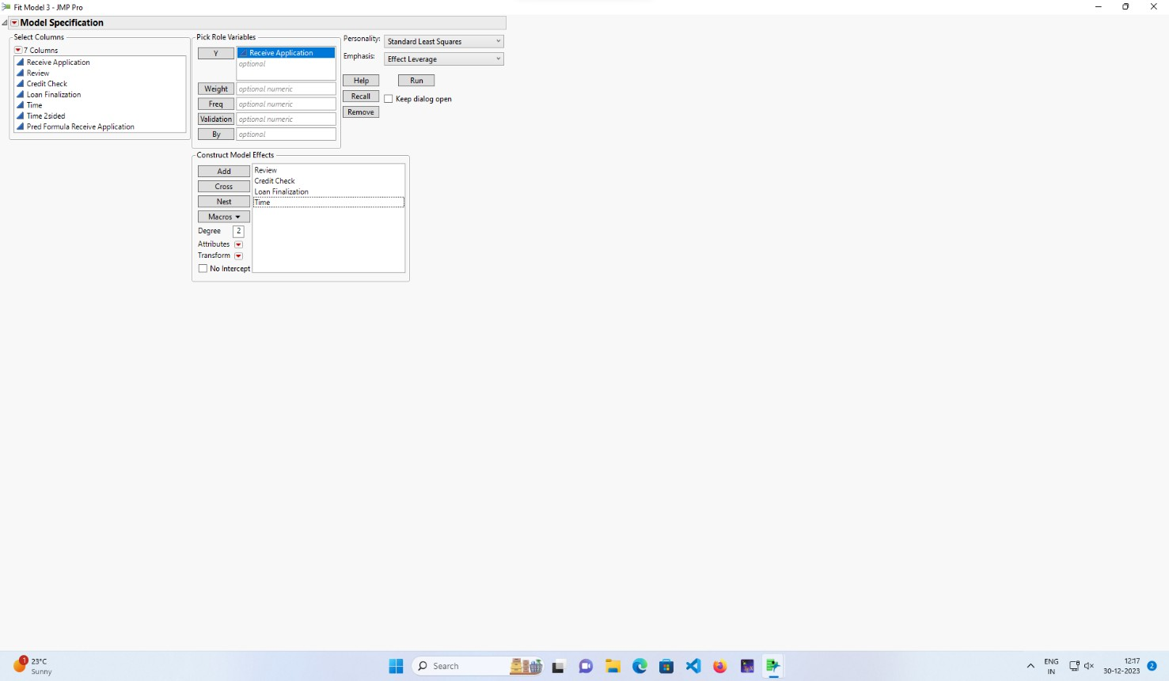

1. After Running, the response receive application will be opened.

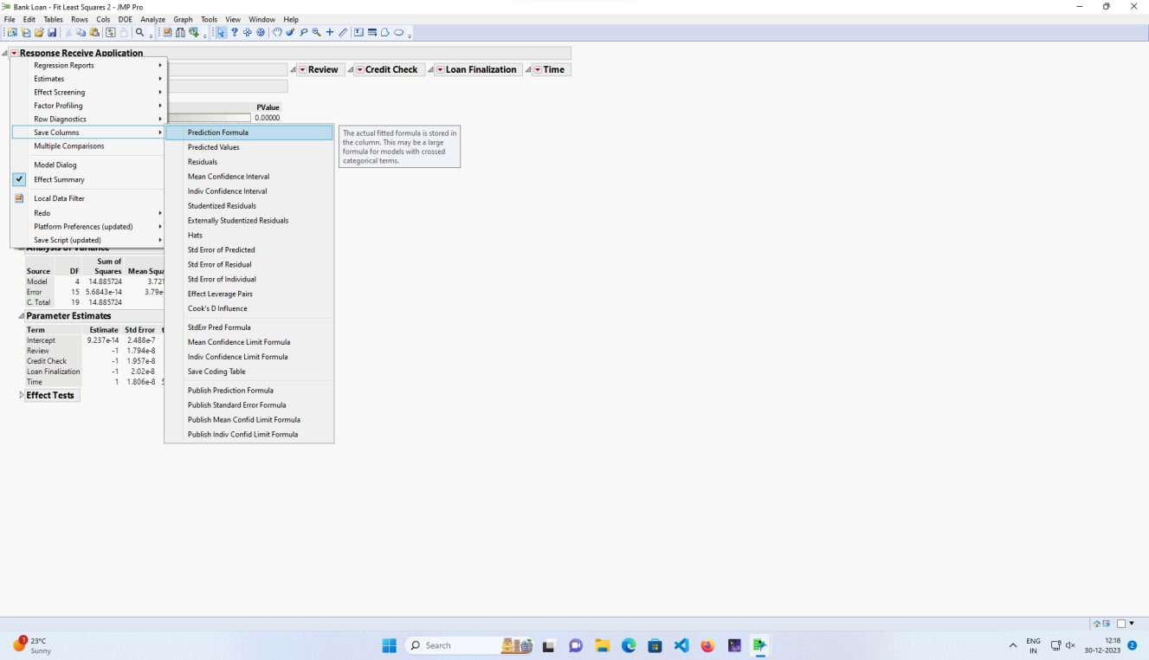

1. From this, the prediction profiler will be activated through the graph profiler activation of required column in dataset.

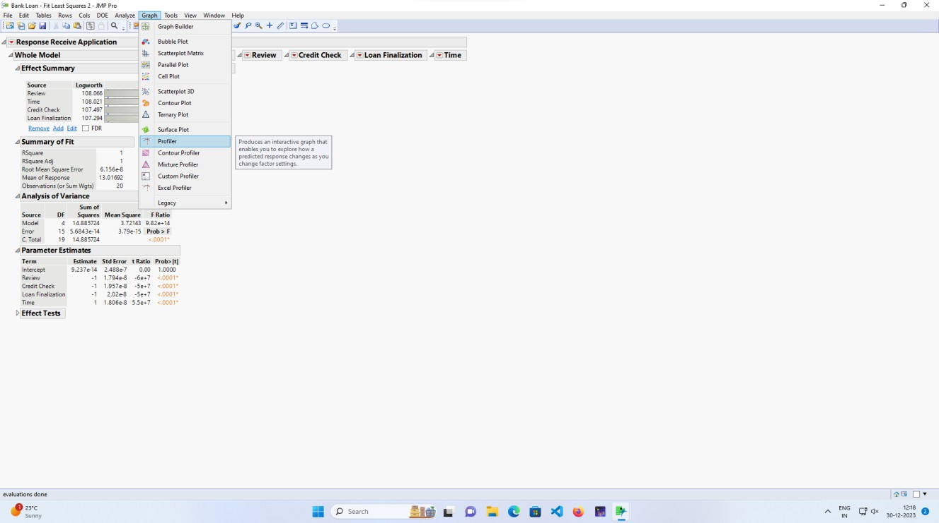

1. Add the column which we created from the RRA.

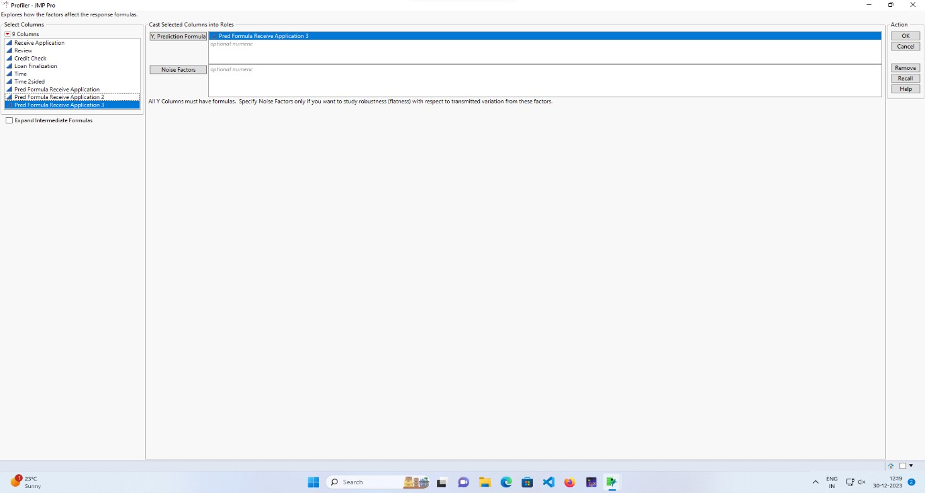

1. Stimulate the output with a number of runs to 100.

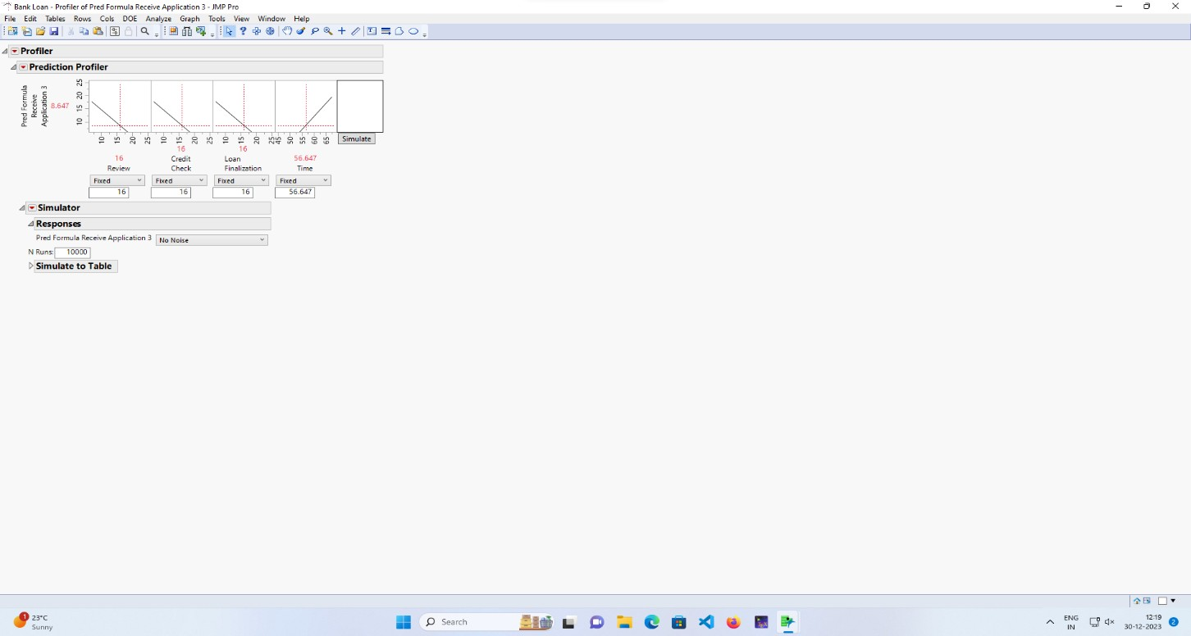

1. Model is complete, finish.

